Assignment : 1

Draw a simple diagram (hand-drawn or digital) showing how your phone connects to Instagram, including your device, WiFi router, ISP, and Instagram server. Label each part and the connections.
Ans :
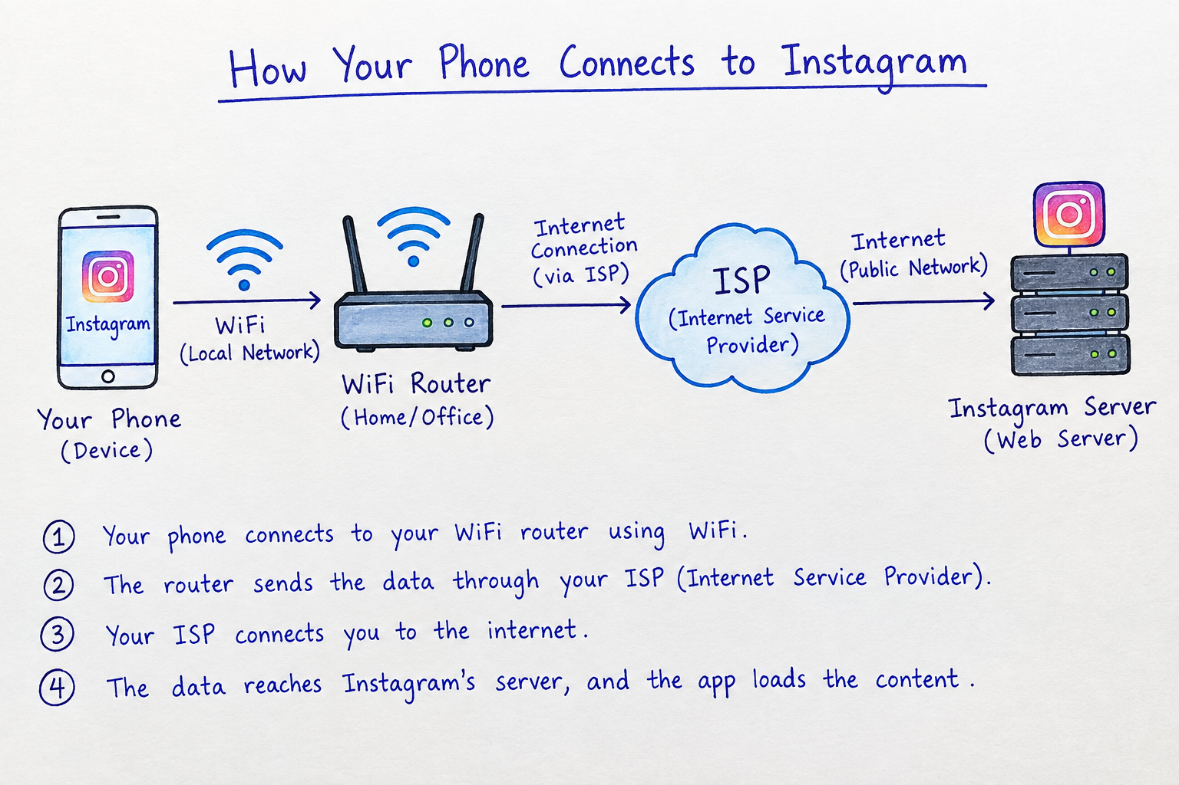

List 5 devices you use or see daily that are part of a network (for example: smartphone, smart TV, WiFi router, laptop, smartwatch). For each, write what type of network it connects to (LAN, WAN, PAN, etc.).
Ans :
No. | Device | Network Type | What it connects to
1 | 📱 Smartphone | WAN | Mobile network / Internet
2 | 📺 Smart TV | LAN | Home WiFi router
3 | 📡 WiFi Router | LAN + WAN | Connects home devices to the Internet
4 | 💻 Laptop | LAN | Home or college WiFi network
5 | ⌚ Smartwatch | PAN | Connects to a smartphone using Bluetooth

Explain the difference between the Internet and an intranet using an example from your college or a public WiFi you have used.
Ans :
Internet | Intranet
A public network used by people all over the world. | A private network used by an organization.
Anyone can access it with an Internet connection. | Only authorized users can access it.
Used to visit websites like Instagram and YouTube. | Used to access internal college resources.
Example: Public WiFi connects you to the Internet. | Example: College WiFi connects you to the college’s internal network.
Example from College
Internet:
When I connect my laptop to college WiFi and open Instagram, I am using the Internet.
Intranet:
When I connect to my college WiFi and access the college’s internal student portal or attendance system, I am using the Intranet.
Pick any one app you use (like WhatsApp, Zomato, or Flipkart) and describe, in 4-5 lines, how data travels from your device to their server and back when you perform a search inside the app.<br><br><em><strong>Hint:</strong> Mention the devices and networks involved, and what happens when you hit 'search'.</em>
Ans :
Example: WhatsApp
- I open WhatsApp on my smartphone and search for a contact or message.
- When I tap Search, my phone sends the request through WiFi or mobile data.
- The request travels through my WiFi router → ISP → Internet → WhatsApp server.
- The WhatsApp server processes the request and sends the matching results back through the same network.
- My phone receives the data, and WhatsApp displays the search results.

